**INSURANCE DATABASE**

Queries of Insurance databases :

Creating Tables :

CREATE TABLE PERSON2 (

driver_id VARCHAR(10) PRIMARY KEY,

name VARCHAR(50),

address VARCHAR(100));

CREATE TABLE CAR2 (

reg_num VARCHAR(10) PRIMARY KEY,

model VARCHAR(30),

year INT,

address VARCHAR(100)

);

CREATE TABLE ACCIDENT2 (

report_num INT PRIMARY KEY,

accident_date DATE,

location VARCHAR(100));

CREATE TABLE OWNS2 (

driver_id VARCHAR(10),

reg_num VARCHAR(10),

PRIMARY KEY(driver_id, reg_num),

FOREIGN KEY(driver_id) REFERENCES PERSON2(driver_id),

FOREIGN KEY(reg_num) REFERENCES CAR2(reg_num)

);

CREATE TABLE PARTICIPATED2 (

driver_id VARCHAR(10),

reg_num VARCHAR(10),

report_num INT,

damage_amount INT,

PRIMARY KEY(driver_id, reg_num, report_num),

FOREIGN KEY(driver_id) REFERENCES PERSON2(driver_id),

FOREIGN KEY(reg_num) REFERENCES CAR2(reg_num),

FOREIGN KEY(report_num) REFERENCES ACCIDENT2(report_num) );

Insetring Values :

INSERT INTO PERSON2 VALUES

('D1','Ravi Kumar','Bengaluru'),

('D2','Anita Sharma','Mysuru'),

('D3','John Mathew','Hubli'),

('D4','Priya Singh','Belagavi'),

('D5','Arun Das','Mangaluru');

INSERT INTO CAR2 VALUES

('KA01AB1234','Hyundai i20',2020,'Bengaluru'),

('KA02CD5678','Maruti Swift',2019,'Mysuru'),

('KA03EF9012','Tata Nexon',2021,'Hubli'),

('KA04GH3456','Honda City',2018,'Belagavi'),

('KA05IJ7890','Ford EcoSport',2020,'Mangaluru');

INSERT INTO ACCIDENT2 VALUES

(101,'2023-01-10','MG Road'),

(102,'2023-02-14','Ring Road'),

(103,'2023-03-20','Airport Road'),

(104,'2023-04-05','NH 48'),

(105,'2023-05-12','Brigade Road');

INSERT INTO OWNS2 VALUES

('D1','KA01AB1234'),

('D2','KA02CD5678'),

('D3','KA03EF9012'),

('D4','KA04GH3456'),

('D5','KA05IJ7890');

INSERT INTO PARTICIPATED2 VALUES

('D1','KA01AB1234',101,15000),

('D2','KA02CD5678',102,30000),

('D3','KA03EF9012',103,25000),

('D4','KA04GH3456',104,5000),

('D5','KA05IJ7890',105,40000);

Output Queries :

SELECT accident_date, location

FROM ACCIDENT2;

SELECT DISTINCT driver_id

FROM PARTICIPATED2

WHERE damage_amount >= 25000;

SELECT P.driver_id, P.name, Pa.damage_amount

FROM PERSON2 P

JOIN PARTICIPATED2 Pa ON P.driver_id = Pa.driver_id

WHERE Pa.damage_amount >= 25000;

select * from CAR2 order by year asc;

Output Screenshots :

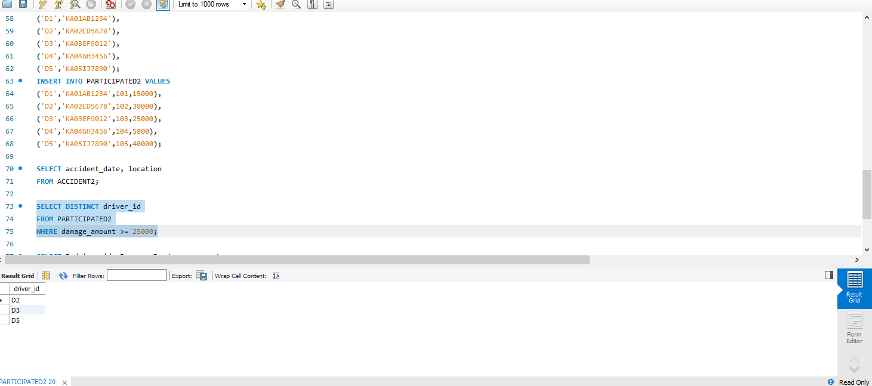

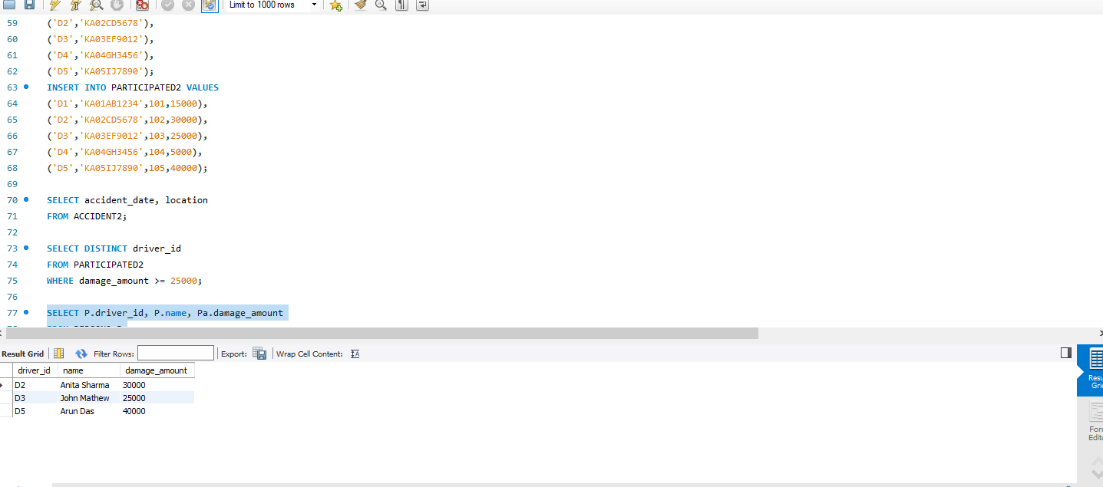

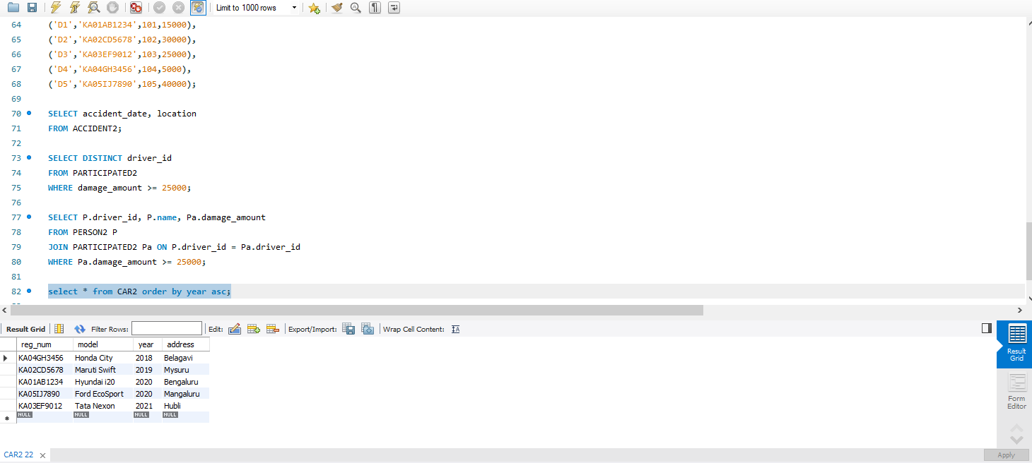

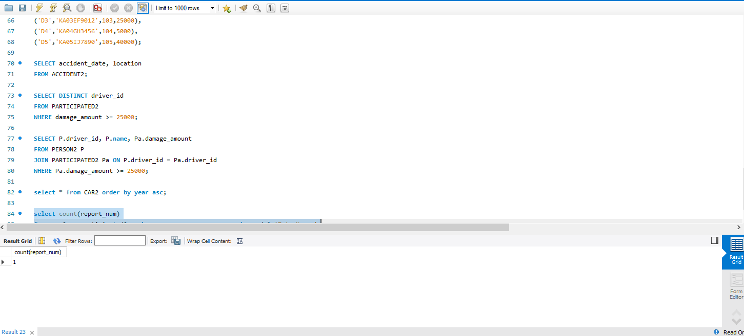

THANK YOU